TEST PLAN

DailyTodo.org

*ChangeLog*

|  |  |  |  |
| --- | --- | --- | --- |
| **Version** | **Change Date** | **By** | **Description** |
| 1.0 | 31.10.2023 | Adi Smajić | Created Test plan |
| 1.1 | 31.10.2023 | Adi Smajić | Added all content |
| 1.2 | 01.11.2023 | Adi Smajić | Added all Test cases |
| 1.3 | 01.11.2023 | Adi Smajić | Added automated tests |
| 1.4 | 02.11.2023 | Adi Smajić | Added UX and bug report |

Table of Contents

Test Prerequisites and Data 3

Test Criteria 4

Abortion of testing 4

Exit Criteria 4

Limitations 4

Test Methodologies 4

Test Automation 5

Test Environment and Tools 5

Estimation 6

Terms/Acronyms 6

Project Base 6

Features To Be Tested (In Scope) 7

Features That Won’t Be Tested (Out of Scope) 7

Defects Handling 7

**Test set Execution** 8

TC no. 01: Create a single task/entry for the ToDo list. 8

TC no. 02: Create multiple task/entries for the ToDo list. 9

TC no. 03: DailyToDo automatically saves the users state tasks after closing browser. 11

TC no. 04: Create multiple tasks/entries and finish/skip few of them for the next day. 12

TC no. 05: Create a task/entry using special characters, symbols and letters. 15

TC no. 06: Remove the DailyToDo title and verify the default one is being used. 16

TC no. 07: Start the DailyToDo list but cancel the entry. 17

**Test Documentation info** 21

**All issues:** 21

**Issue no. 01: DailyToDo accepts empty tasks/entries (F/UI/UX)** 21

**Issue no. 02: DailyToDo history returns a potentially unsorted table (UX)** 22

**Issue no. 03: DailyToDo does not accept duplicated tasks (unclear) (UX)** 23

**Issue no. 04: DailyToDo table width changes on mobile devices (UI)** 25

GENERAL ANALYSIS OF THE USER EXPERIENCE ISSUES: 31

## Test Prerequisites and Data

Before testing phase:

- Test plan document.

- Test cases documented.

- Test Design specifications.

Precondition for the start of the testing phase is a working website for the user.

https://dailytodo.org/

During testing phase:

- Test Tools specified.

- Simulators (N/A).

- Test Data.

- Error logs and execution logs (N/A).

After testing phase:

- Test Results/reports.

- Defect Reports.

- Release notes.

# Test Criteria

Testing will be considered complete when the following conditions have been met:

• 100% test coverage

• All Manual & Automated Test cases executed

## Abortion of testing

If the tester reports that at least one high priority test cases failed, he will immediately suspend testing until the developers fix all bugs and issues.

If the main tester reports >**50%** of the medium priority test cases failed, he will immediately suspend testing until the developers fix all bugs and issues.

No criteria for the low priority bugs/issues as they can be updated over a period of time.

## Exit Criteria

No present bugs/issues in the high priority level.

No more than 50% remaining medium priority bugs/issues to be fixed.

# Limitations

|  |  |
| --- | --- |
| **Limitations** | **How to overcome them** |
| N/A |  |
| N/A |  |

# Test Methodologies

For the DailyToDo website there’re 2 main types of testing that should be conducted:

1. Positive/Negative testing
2. Non-functional testing

|  |  |
| --- | --- |
| Name: | Description: |
| **UX testing** | Analyzing the flow of the application and usability as a form of quality measure for design. |
| **Automated testing** | Involves testing the main functionalities of the web application using the manual TC as a template and UI web components |
| **Exploratory testing** | Simultaneous learning, test design and test execution |
| **Monkey testing** | Quick testing by the QA not familiar with the website. Repeating flows over and over again with different random interactions. |

## Test Automation

Automated functional test is planned at this time. The main goal of automation testing is to ensure that all functionalities work in accordance with certain requirements. It can significantly reduce the time it takes to test products because it runs quickly and efficiently. This puts time back into the hands of developers and production managers, who can divert their efforts into other aspects of the project. It can greatly boost productivity as a result.

# Test Environment and Tools

As of now, a native application of the DailyToDo website doesn’t exist. In that case, our focus is on the desktop version and web browsers.

We will cover all major and most popular web browser during our testing (and additional if required).

|  |  |
| --- | --- |
| Process | Tool |
| **Defect Tracking** | MS Word |
| **Test Cases** | MS Word |
| **Automation Framework** | Cypress/Mocha |
| **Environment/IDE** | Visual Studio |
| **Programming language** | JavaScript |
| **Operative system** | Windows 10 |
| **Versioning** | GIT |
| **Browser** | Google Chrome, Firefox, Microsoft Edge |

Main test environment

|  |  |
| --- | --- |
| Name: | Version: |
| Google Chrome | 118.0.5993.120 |

# Estimation

2 days

# Terms/Acronyms

| TERM/ACRONYM | DEFINITION |
| --- | --- |
| TC | Test Case |
| Precondition | A necessary action/data before the execution of the TC |
| Data | Pre-generated string from the QA that is used in the TC (optional) |

# Project Base

DailyToDo is a simple web application tool that lets you track your daily tasks. No registration or sign-up required. After entering the website, the user can immediately create a personalized Todo list with at least one or more tasks each separated in a new line.

Upon saving the user is presented with a table containing previously inserted tasks for each row and their current default unchecked status for Today’s date, aswell as a number of other columns representing past dates also in a default unchecked state because these tasks could not have been completed if this is the users’ first time using DailyToDo. After completing a task in real-time, the user can first navigate back to DailyToDo.org, and then click in the Today column the checkmark option in order to mark the task as done for that day, as a result the checkmark will turn green.

The user is also able to uncheck the same task in order to return it to its default unchecked status. One great feature about this website is that even though the user is not signed in or registered, the Tasks and column statuses retain the users’ actions even after closing the web browser and returning back to the website. After the date changes to one day ahead, the table will automatically update and tasks which were not checked as finished the day before will have a red checkmark, or green if finished, their statues remain permanent. The history of statuses for each task can be found in the last “Older” column located on the right side.

This document describes the methods that we will be used to evaluate and specifies the functions and processes for DailyToDo.org. In this document there is detail information about scope, approach, resources, and schedule of all testing activities of the project.

The goal of the testing is the thorough verification of the most key features with the typical scripts of its usage. By using the test documentation in this way, we will ensure the usability of the product.

# Features To Be Tested (In Scope)

* Creating new tasks
* Editing existing tasks
* Completed/Not completed statuses
* Saved state
* Changes within a time frame
* UX

# Features That Won’t Be Tested (Out of Scope)

* API components
* Specific environments and devices
* Performance, load testing
* Excessive UI reviews

# Defects Handling

N/A

|  |  |  |  |  |  |
| --- | --- | --- | --- | --- | --- |
| Type of Defects | Functionality | Performance | Security | Usability | Compatibility |
| Critical | x |  | x |  |  |
| Major | x |  | x | x |  |
| Minor |  | x |  |  | x |
| Cosmetics |  |  |  | x | x |

# **Test set Execution**

### TC no. 01: Create a single task/entry for the ToDo list.

**Data: “**a_random_entry”

**Precondition:** Open the website <https://dailytodo.org/>

**Steps:**

**1)** Click on the Create your Daily Todo list button.

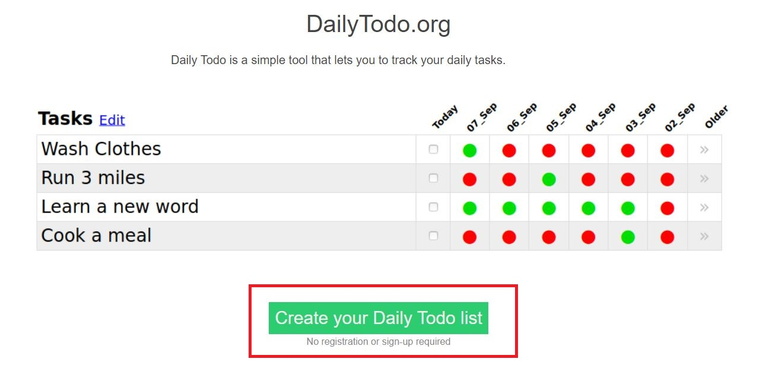

**2)** Use the text provided in the Data section or write a random input.

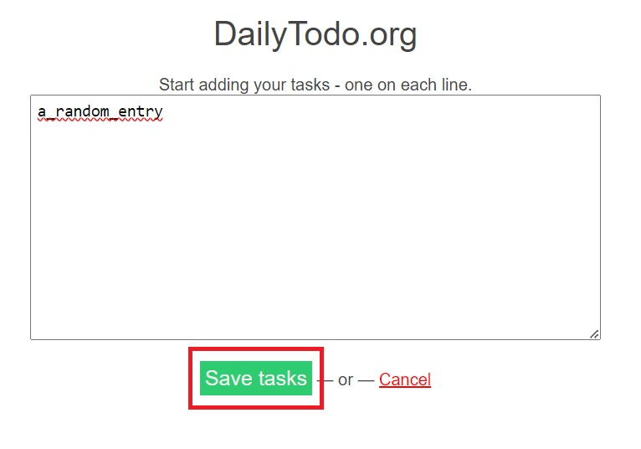**3)** Click Save task button.

**4)** Verify the entry is successfully saved and displayed on the Tasks for today table. Verify the entry has no completed checkmark in the Today column

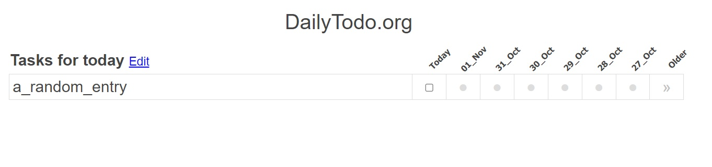

### TC no. 02: Create multiple tasks and select the second as completed.

**Data:**

**“**First entry  
Second entry  
Third entry”

**Precondition:** Open the website <https://dailytodo.org/>. If the DailyToDo list already has previous entries, open the website in incognito mode.

**Steps:**

**1)** Click on the Create your Daily Todo list button.



**2)** Use the text provided in the Data section or write a number of tasks, each separated in a new line using the “Enter” key.

**3)** Click Save task button.

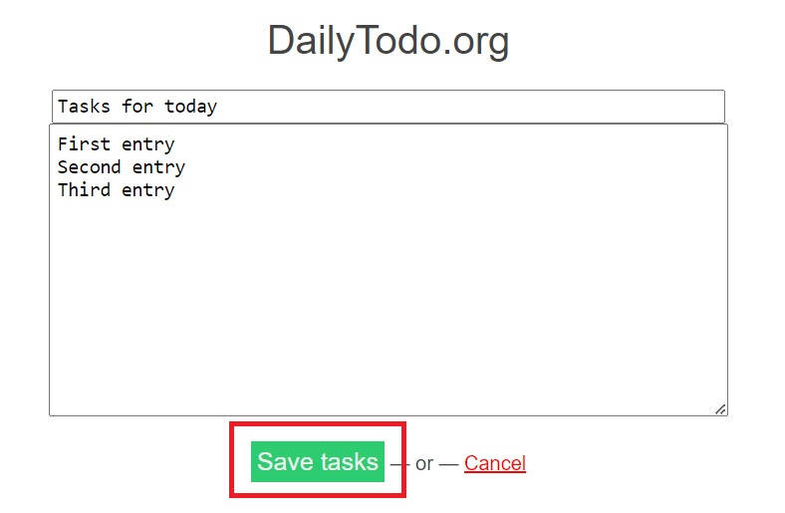

**4)** Verify the entry is successfully saved and displayed on the Tasks for Today table. Verify that no entries have a completed/green checkmark in the Today column

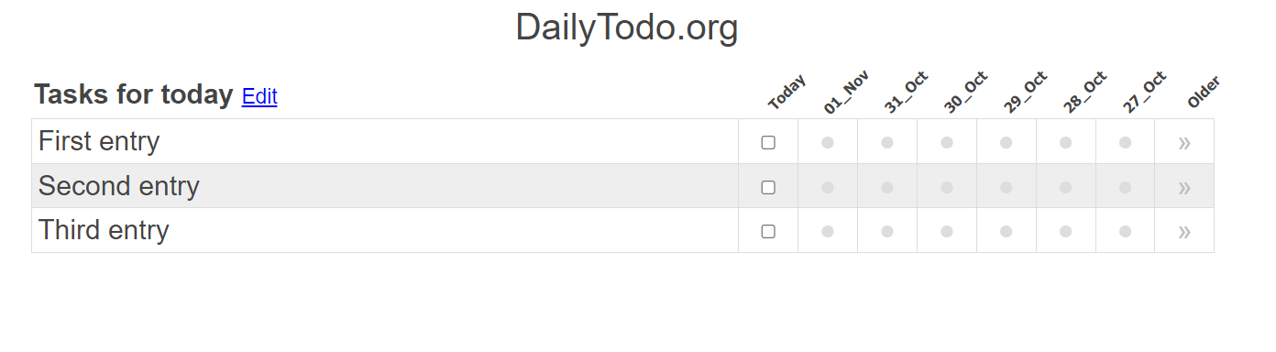

**5)** For the second entry, select the checkmark under the Today column. Verify the checkmarks turns to green indicating a finished status.

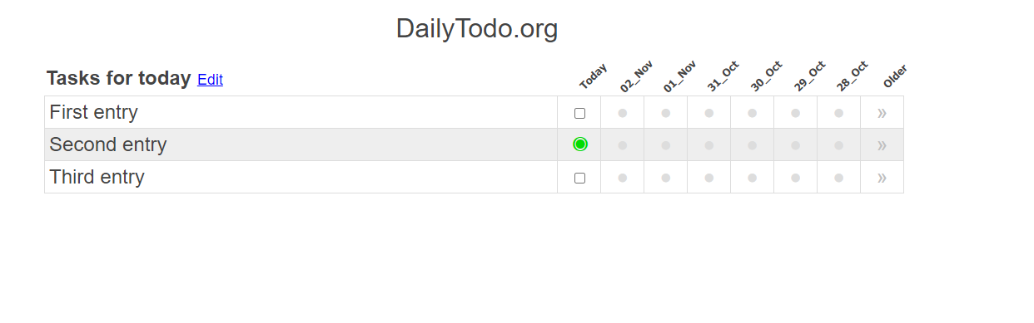

### TC no. 03: DailyToDo automatically saves the users state tasks after closing browser.

**Precondition:** Open the website <https://dailytodo.org/>. Execute and complete “TC no. 1” or “TC. 02”.

Steps:

**1)** Note down the unique URL link from the web address aswell as the current entries/tasks.

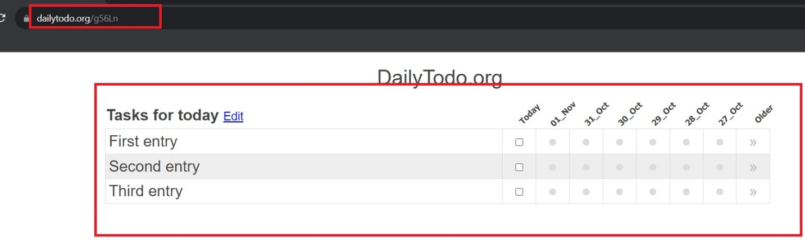

**2)** Exit/close the web browser, if possible restart your device too.

**3)** Open the website <https://dailytodo.org/> again. Verify that both the URL and the previous entries/tasks are restored.

### TC no. 04: Create multiple tasks/entries and finish/skip few of them for the next day.

**Precondition:** Open the website <https://dailytodo.org/>

**Steps:**

**1)** Click on the Create your Daily Todo list button.



**2)** Write a number of tasks, each separated in a new line using the “Enter” key.

**3)** Click Save task button.

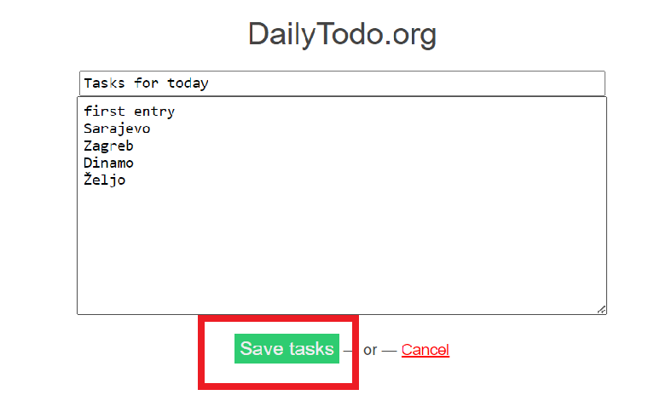

**4)** Verify all tasks are displayed in the table. Arbitrarily chose a number of tasks as completed, click on the checkmark below the Today column. Also leave a number of them unchecked.

**5)** Note down the current state of the table, also again note down the URL link from the web address.

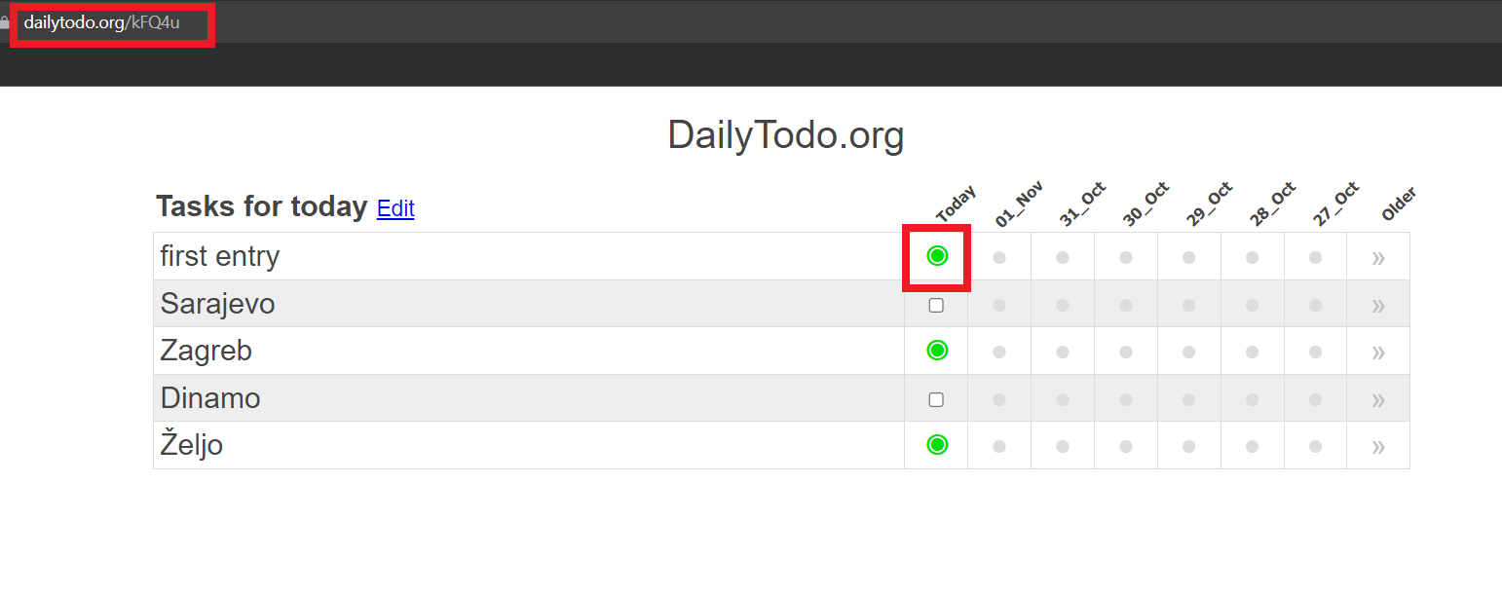

**5)** Close the web browser, if possible shutdown or restart your device.

**6)** Wait until the next day. Open the website <https://dailytodo.org/> again.

**8)** Verify the tasks in the table have the same entries as the previous day, in the same order.

Verify the URL link is the same as previously noted.

Verify the second column shows the date from the previous day.

Verify the checkmarks from the completed tasks from yesterday are green, and the checkmarks from the skipped tasks are red, in the second column.

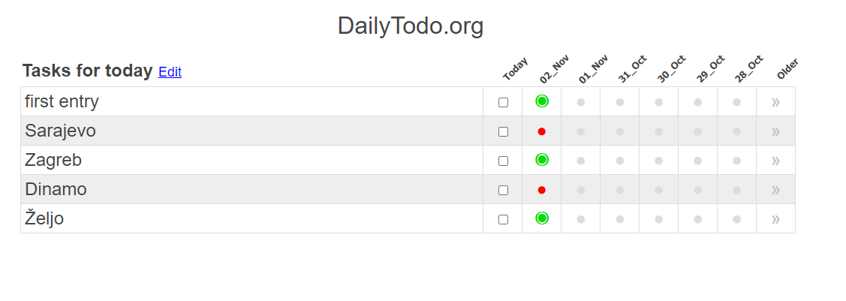

### TC no. 05: Create a task/entry using special characters, symbols and letters.

**Data: “**EdjBhS234_!$%&/?]{¤×ЊЩЯ𡨸漢 الْأَبْجَدِيَّة الْعَرَبِيَّة,dאָ־בֵּית עִבְר”

**Precondition:** Open the website <https://dailytodo.org/>

**Steps:**

**1)** Click on the Create your Daily Todo list button.



**2)** Use the text provided in the **Data** section or write a random entry containing special characters and symbols.

**3)** Click Save task button.

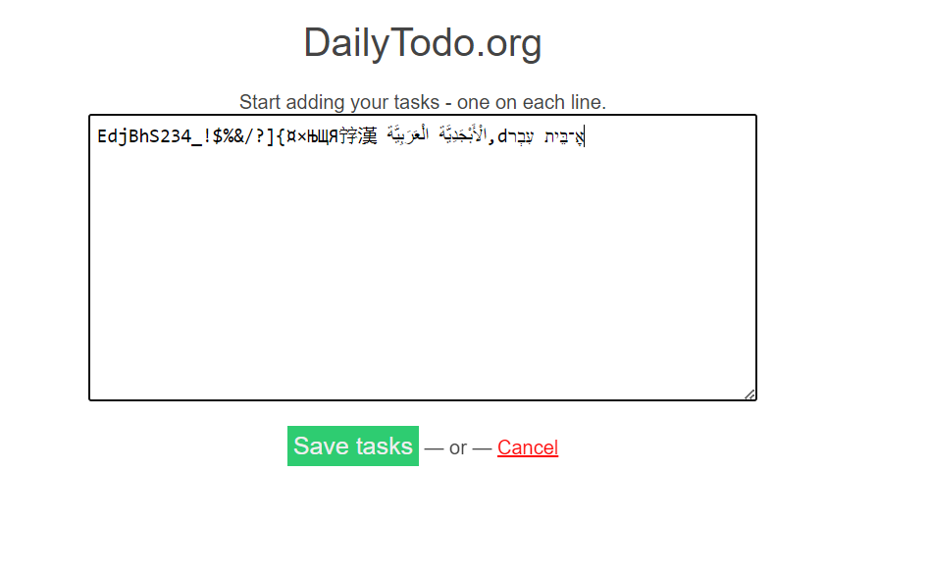

**4)** Verify the entry is successfully displayed in the table.

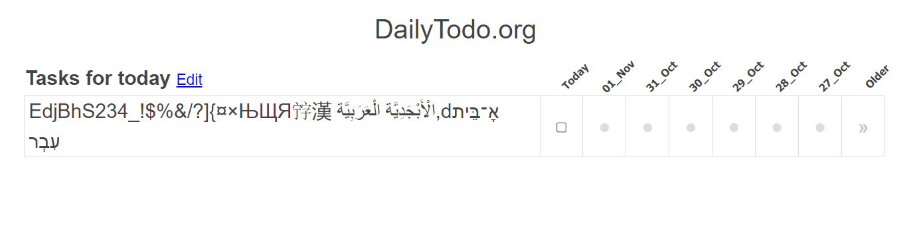

### TC no. 06: Remove the DailyToDo title and verify the default one is being used.

**Precondition:** Open the website <https://dailytodo.org/>. Execute “TC no. 01” or “TC no. 02”

**Steps:**

**1)** Click on the Edit button next to the “Tasks for today” title.

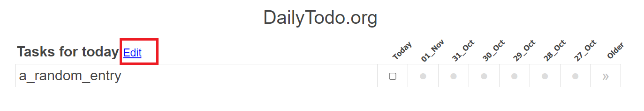

**2)** Delete the text from the title and click on Save tasks button.

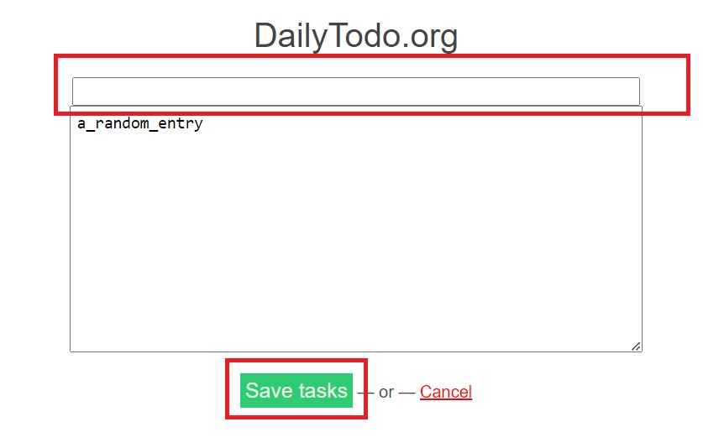

**3)** Verify the title in the ToDo table returns back to its default title “Tasks for today”

### TC no. 07: Start the DailyToDo list but cancel the entry.

**Data: “**a_random_entry”

**Precondition:** Open the website <https://dailytodo.org/>

**Steps:**

**1)** Click on the Create your Daily Todo list button.

**2)** Use the text provided in the Data section or write a random input.

**3)** Click the Cancel button.

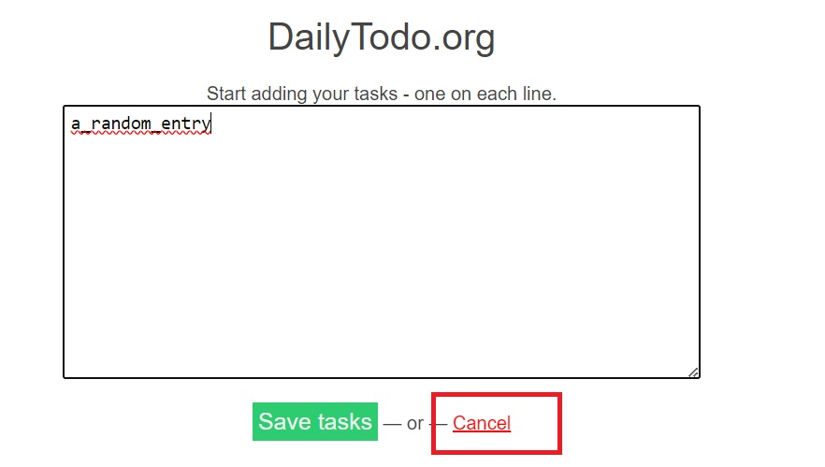

**4)** Verify that no entry is shown and the user is navigated back to the home page.

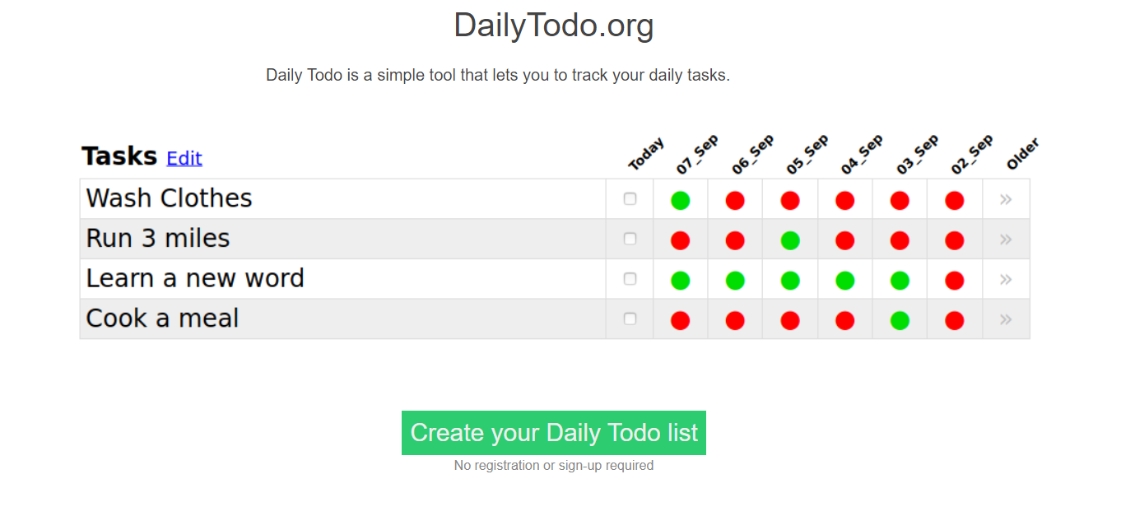

BUG REPORT

DailyTodo.org

## **Test Documentation info**

**Type of Issue:**

* Functional Bug (F)
* User Interface issue (UI)
* User Experience issue (UX)

**Priority:**

* **High**
* **Medium**
* **Low**

# **All issues:**

## **Issue no. 01: DailyToDo accepts empty tasks/entries (F/UI/UX)**

**Precondition:** Open the website <https://dailytodo.org/>

**Steps to reproduce the issue:**

1) Click on the Create your Daily Todo list button.

2) Click on Save tasks button leaving the task field empty.

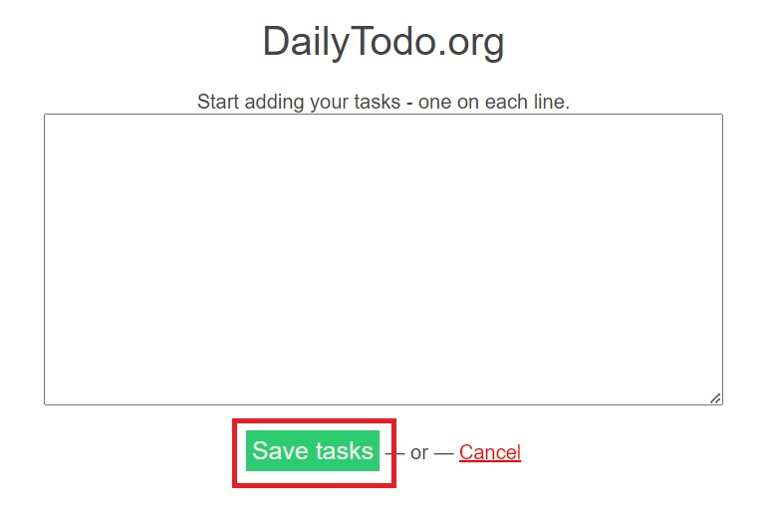

**Expected Results:** The Save tasks button is disabled, the user can only Cancel the entry.

**Results:** The user can Save the empty tasks resulting in an unexpected User Interface.

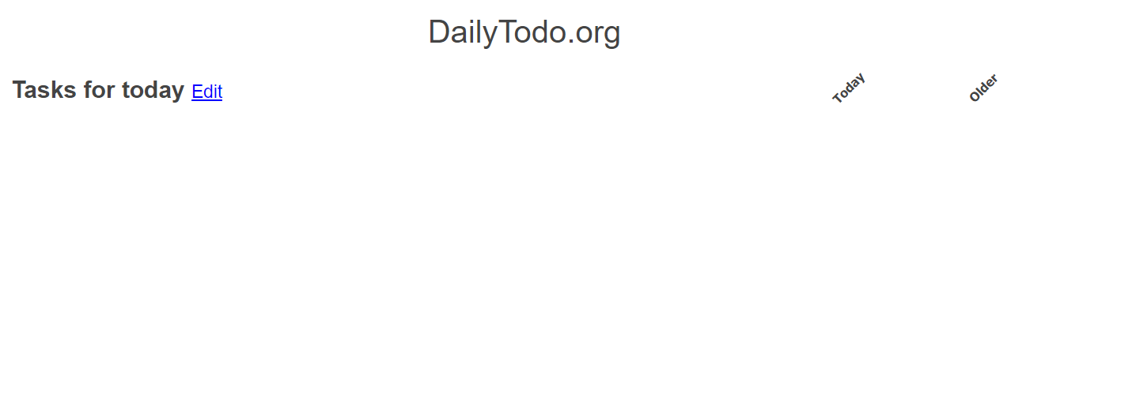

## **Issue no. 02: DailyToDo history returns a potentially unsorted table (UX)**

**Precondition:** Open the website <https://dailytodo.org/> and create one task

**Steps to reproduce the issue:**

**1**)Click on the button below the Older column section

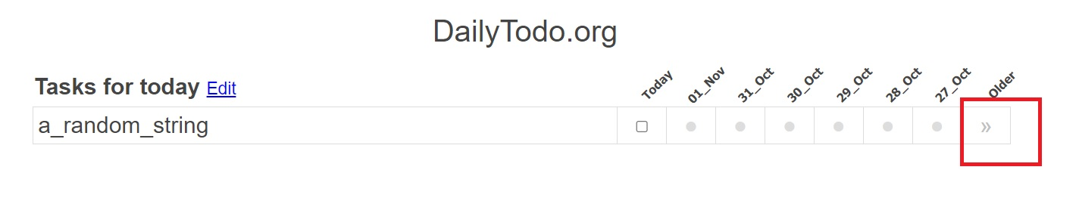

**Results:** The user is presented with a history diagram of the selected task. Every row represents the same current day when the task is selected (i.e. thursday as the current day for the task), and every box in the same row represents the same day (Thursday) with a different date for the current, previous and upcoming month. The row above shows Wednesday, the row belove Friday. The problem is the unclear logic and structure behind this. The average user would expect to see the progress for every date one after the other just like in any calendar application or other ToDo lists.

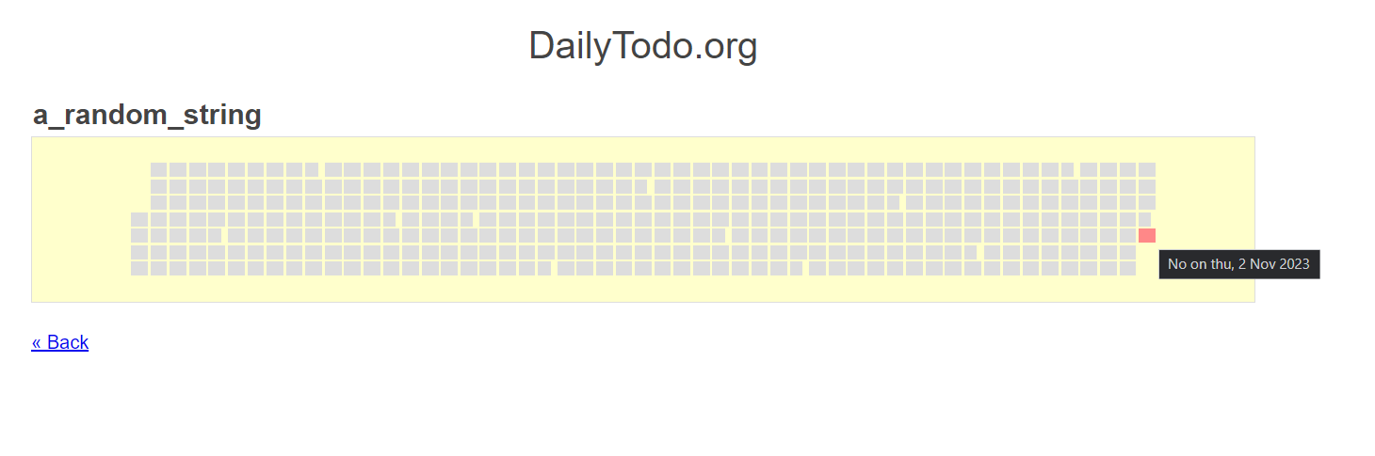

## **Issue no. 03: DailyToDo does not accept duplicated tasks (unclear) (UX)**

**Precondition:** Open the website <https://dailytodo.org/>

**Steps to reproduce the issue:**

1) Click on the Create your Daily Todo list button.

2. Enter two entries/tasks with the same name, one in each row, and click on Save tasks button.

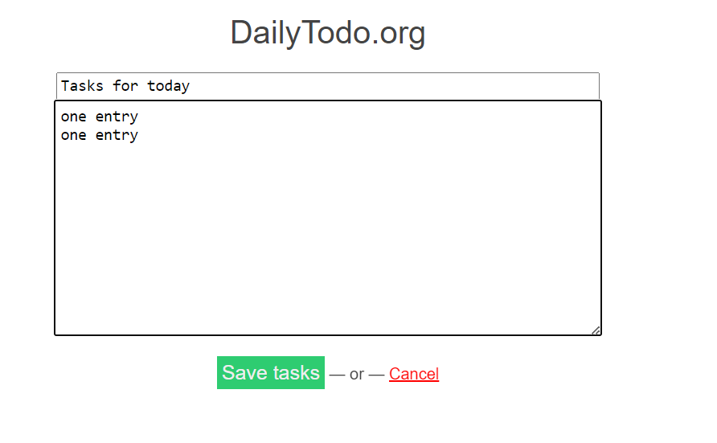

**Results:** DailyToDo doesn’t not allow duplicated entries/tasks and ignores the second task.

**Expected results (unclear):** The user is able to enter duplicated tasks/entries.

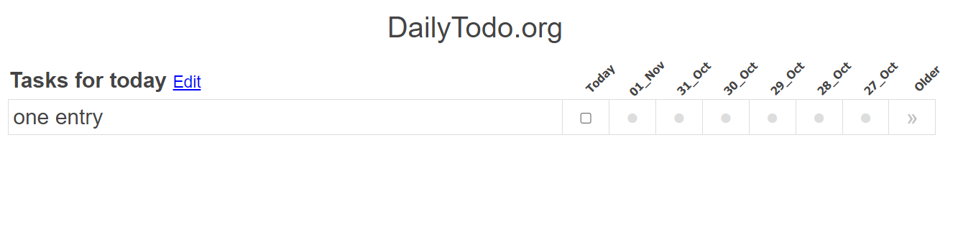

## **Issue no. 04: DailyToDo table width changes on mobile devices (UI)**

**Precondition:** Open the website <https://dailytodo.org/> using a mobile device

**Steps to reproduce the issue:**

**1)** Click on the Create your Daily Todo list button.

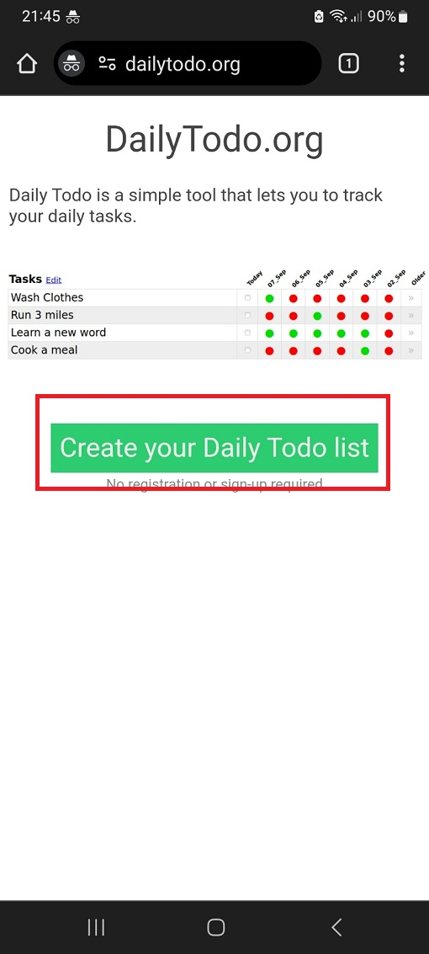

**2)** Write a new entry/task and click Save tasks button.

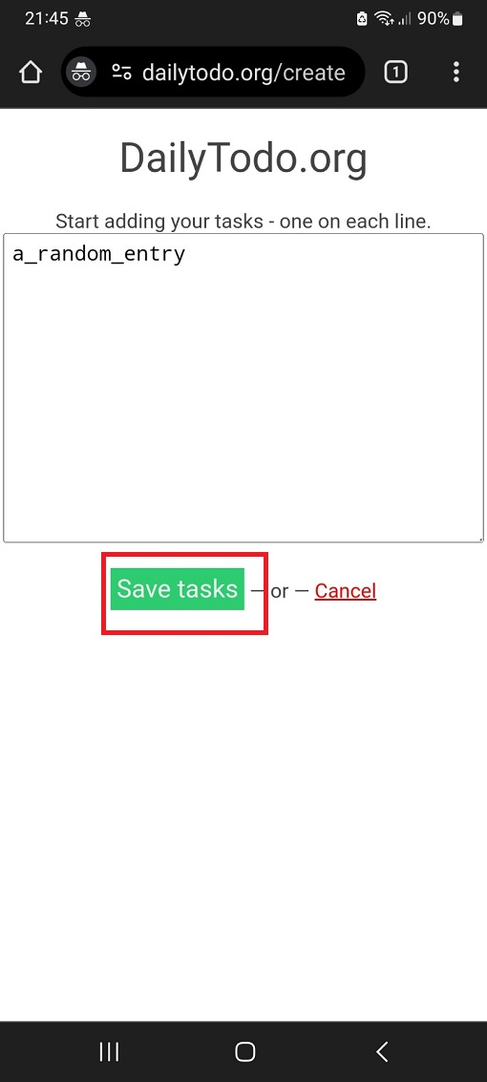

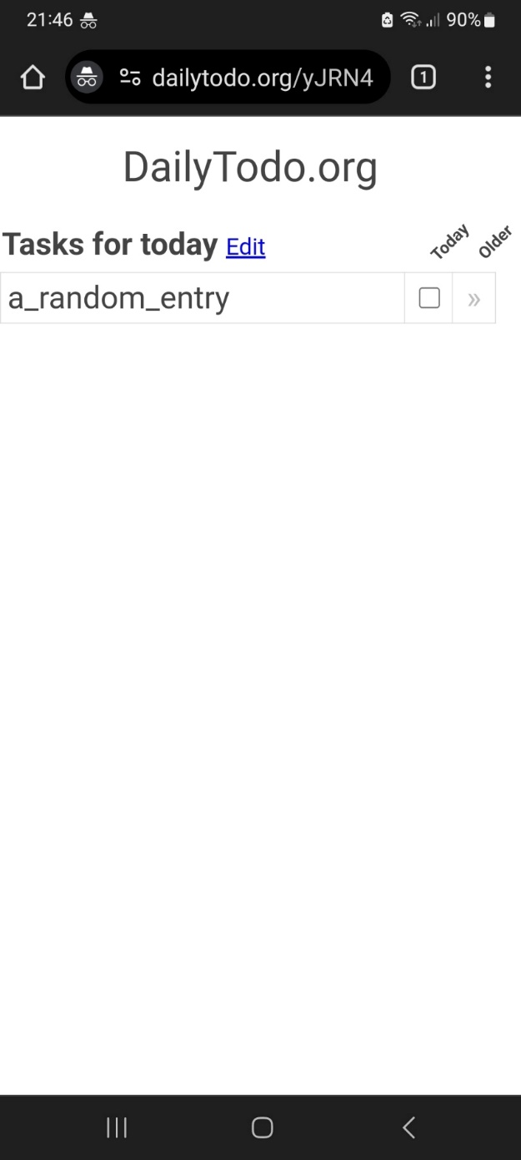

**Results:** Due to entry/task text length only one (Today) column is displayed.

**3)** Click on the Edit button and change the entry/task text to a single letter. Click on Save tasks button.

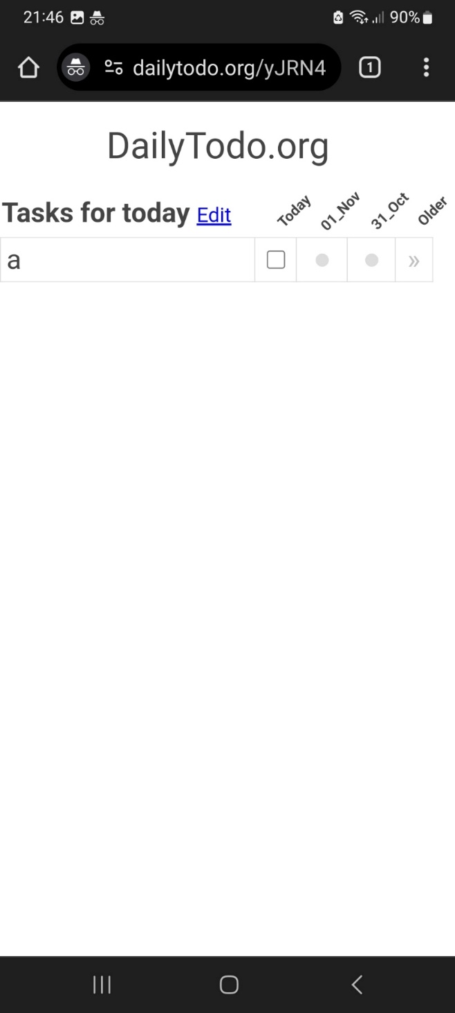

**Results:** Two more columns are being displayed.

**4)** Click on the Edit button again, rotate the phone horizontally, don’t change anything and click on Save tasks button.

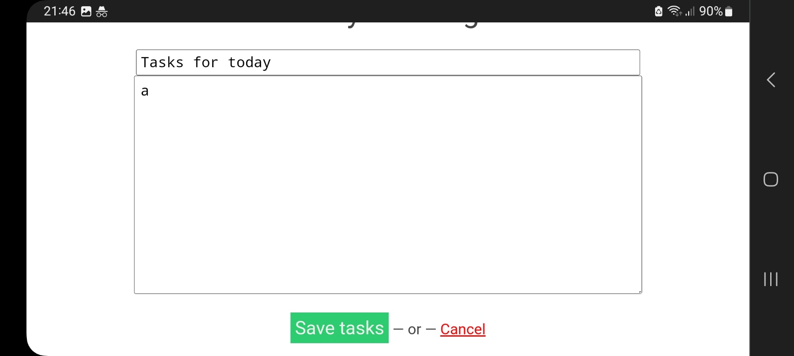

**Results:** The number of columns increased again.

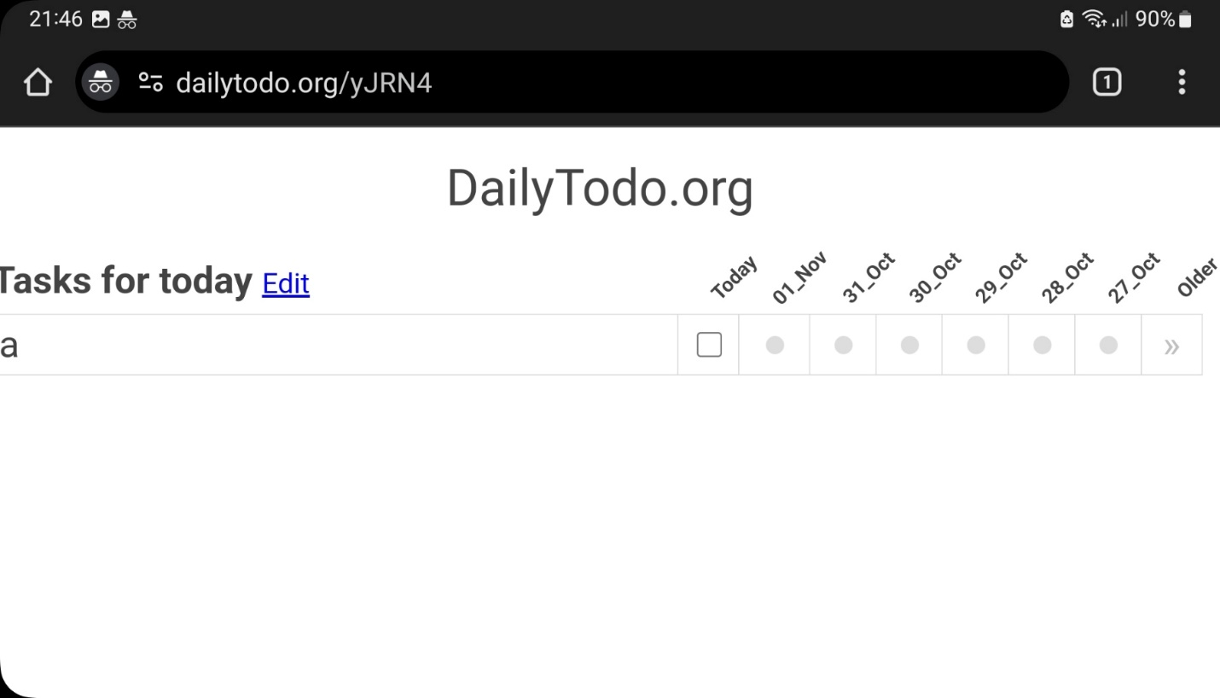

**5)** Rotate the phone back vertically.

**Results:** Notice the difference now and the table in step 3).

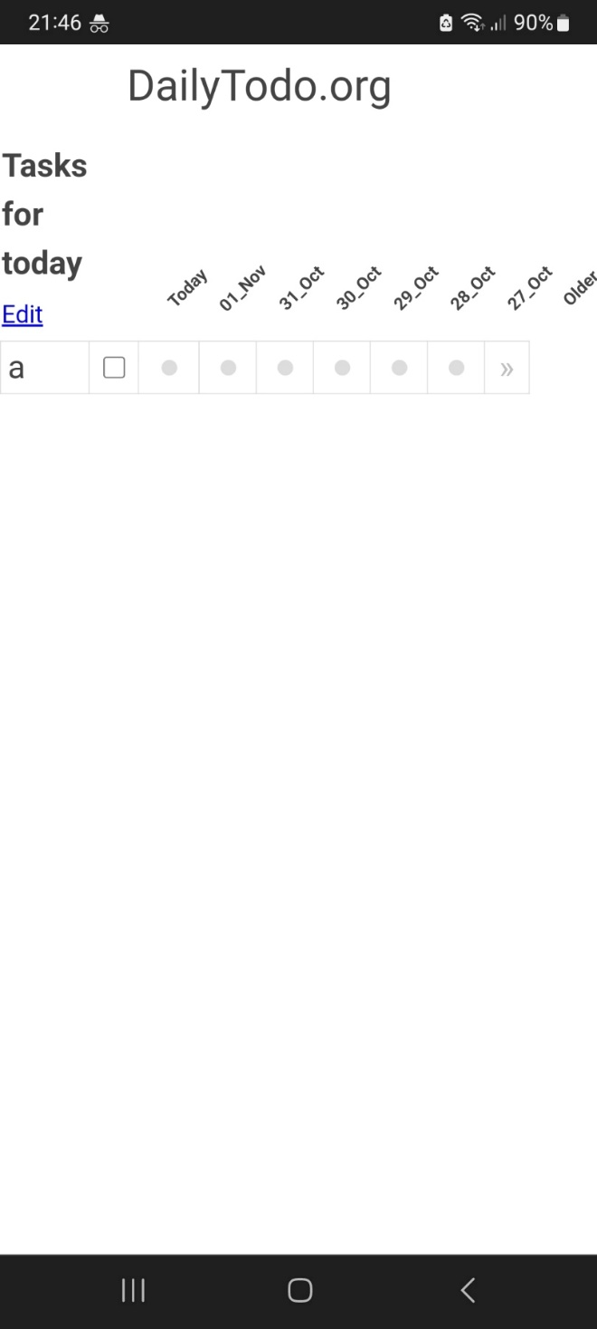

# GENERAL ANALYSIS OF THE USER EXPERIENCE ISSUES:

A general UI design "problem" prevails along the application but it's obvious that the goal was to hit the focus on simple functionalities without concerning much about future changes or trends to follow therefore some minor UX problems are present but no blocking issues for the users. The basic characteristics of this application is that a minor change in the design automatically changes the user experience itself, because despite the simplicity and lack of options, a certain number of things can be completely removed to make the general concept of the application more acceptable and natural.

At the very beginning is the DailyToDo.org homepage, where we come across a finished example of a table that the user will soon encounter. What is contradictory is that this type of application must be self-intuitive, where the user overcomes obstacles on his own and leads himself to the final result based on what he expects to see, on the basis of previous experiences and on the basis of the very simplicity of the application, where even if you make a mistake, the same mistake can be self-intuitively corrected very quickly.

Therefore, this example must be removed from the page because it creates confusion, because the goal is for users to learn by themselves, and not to waste time analyzing an image that does not look like an image in itself, but something that the user may need to delete, click or edit. The edit button immediately points to it.

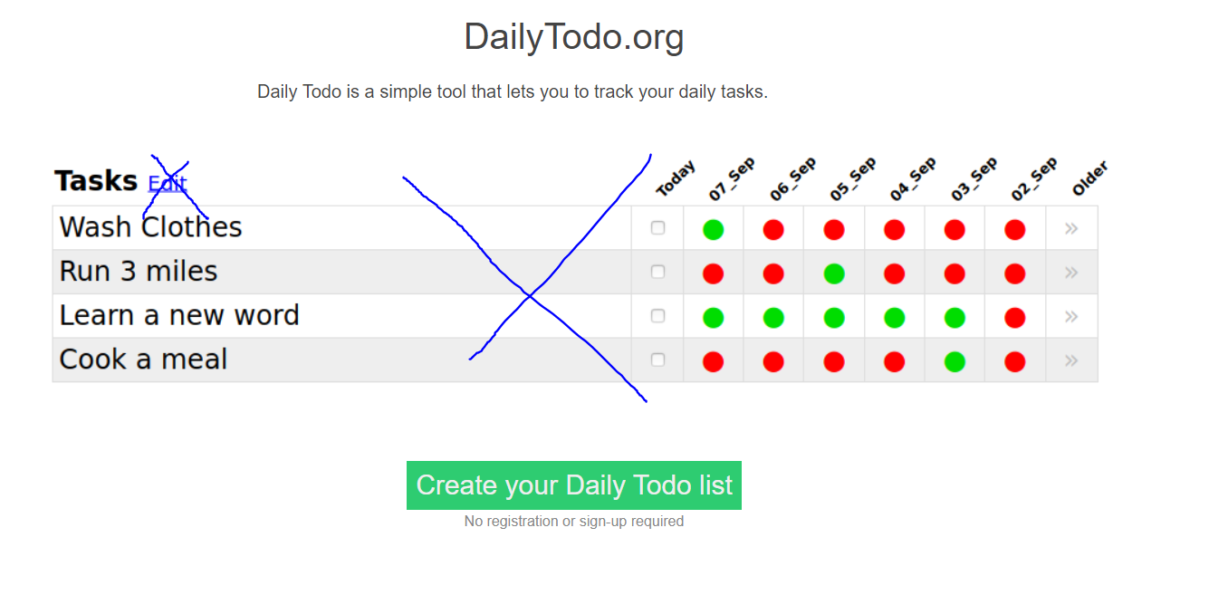

Below the main "call to action" Create your Daily Todo list button, we can find information that aims to show one of the main advantages of this application, which is really a big advantage, the problem with this message is that it should not exist at all. Because, the average user will never think about registering or logging in until it is offered to him. Maybe there is a smaller number of people who are used to it, so they avoid clicking buttons that look "too good to be true" where they get something free + fast. We have many such examples with larger services that offer the creation of websites, e-commerce or forums. However, with such applications, the user should not waste time reading information that he neither imagined nor wanted to know, he will certainly find out unconsciously.

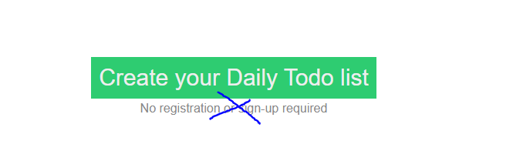

Considering the size of the text and the conspicuousness of other elements, a short description of the application, which is very interesting, is hidden under the h1 DailyToDo title, and that description can reveal more to the user what follows than the example below it. We all know roughly what ToDo lists, tasks or spreadsheets look like without unnecessary tutorials or examples.

The lack of CSS styling on button elements means that users are certainly not sure at times whether a button can be clicked, because there is no hoover effect or cursor change.

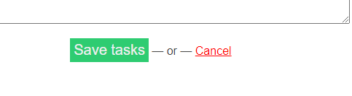

While on the other side, there is excess functionality on the DailyTodo.org headline, which is located on every screen where the user has the option to return to the home screen of his table.

It wouldn't be a bad solution if there weren't "back" & “cancel” buttons for the same functionality, which are also barely visible. In this way, we create shortcut paths that take the user back one step, therefore we unnecessarily create more choices for the user, one of which is not clear what exactly it does, unlike the "back" button. And the "back" button, as we have already mentioned, is not even visible due to the excessive "white space" that dominates the screen, at least on the desktop version.

A simple solution would be to center everything and completely remove the white background, which gives a counter-effect and eats up all important elements instead of emphasizing them.